Contact: Bob O’Donnell
TECHnalysis Research, LLC
Phone (650) 224-2355
bob@technalysisresearch.com

Press Release

TECHnalysis Research Forecasts Seismic Device Shift as Large Smartphones Expected to Outsell Small Tablets and Notebooks in 2014

Total Smart Connected Devices to Peak in 2017 as Saturation and Longer Lifetimes Slow Growth
Foster City, CA, February 3, 2014: TECHnalysis Research, LLC announced the release of its first market forecast highlighting the dramatic changes happening in the world of smart connected devices. Specifically, the firm believes that worldwide unit shipments for the large smartphone category (those with screen sizes of 5” or larger—commonly called “phablets” but perhaps better termed “mobile connected devices”) will reach just over 240 million units in 2014 versus 173 million notebooks and 158 million small tablets (those with screen sizes between 7-8”). The total market for smart connected devices is expected to grow from 1.54 billion units in 2013 to 2.06 billion in 2018, but that’s a small drop from the projected peak of 2.07 billion in 2017.
“Even the hottest device categories can’t keep growing forever,” commented TECHnalysis Research founder and chief analyst Bob O’Donnell, “and we believe the slowdowns that have started to occur in the US and other developed regions will start to impact the developing regions by the end of the forecast period.”
Looking at the results by category shows that PC shipments are expected to continue their decline for the next few years, but then level out in the 292 million unit range by 2016. Tablets are expected to continue growing throughout the forecast period, but will see very modest single-digit growth rates in the final years of the forecast, ending in shipments of 339 million in 2018. Smartphones are forecast to peak in 2017 at around 1.44 billion units but then slip to 1.43 billion in 2018. The big story in smartphones, however, is the move to larger sizes as TECHnalysis Research predicts approximately one of three smartphones shipping worldwide in 2018 will have a 5” screen or larger.
In the US, the total market for smart connected devices is also expected to peak in 2017 at a volume of nearly 279 million units, but starting in 2015 year-over-year growth rates will fall to under 2%, leading to a relatively stagnant level of unit shipments. US PC shipments will hover in the 58 million unit range starting in 2015, while tablets will grow from 58 million units in 2013 to nearly 74 million in 2018. Smartphone shipments are expected to peak in 2016 at 149 million units and then drop to 145 million units in 2018, although all of that decline will be in smaller smartphones (those with screens under 5”), as the larger smartphone category will grow through the forecast period and reach 30% of all US smartphone shipments in 2018.
Some of the other highlights from the forecast include:
- Android-based smart connected device shipments will hit 1.1 billon this year, but Android’s share of the total will also peak in 2014 at 62.5% and then decline modestly over the forecast period.
- Apple’s overall share of smart connected devices is forecast to hit 19.7% by 2018 while Microsoft’s share will be 19%.
- The US share of total worldwide Smart Connected Device shipments will fall from a peak of 22.6% in 2010 to 13.5% in 2018.
- Revenues for US-based sales of Smart Connected Devices are expected to continuously decline throughout the 5-year forecast from their peak in 2013 due to slowing growth and lower prices.
The TECHnalysis Research forecast offers a 5-year forward-looking view into unit shipments, average selling prices and revenues both worldwide and in the US for PCs, tablets and smartphones. The forecast also breaks the numbers out by form factor within each group (e.g., small tablets vs. large tablets), by consumer and commercial splits, and by operating system.
“We are in the midst of a dramatic recasting of the entire market for devices,” said O’Donnell. “In fact, you could argue it’s leading to a complete redefinition of what computing is, what computing means and where computing happens. As a result of these changes, there will likely be enormous shifts in power and influence across vendors, across ecosystems and across geographical regions. It’s safe to say that the world of computing and intelligent devices will look very different in 5 years compared to what it is today.”
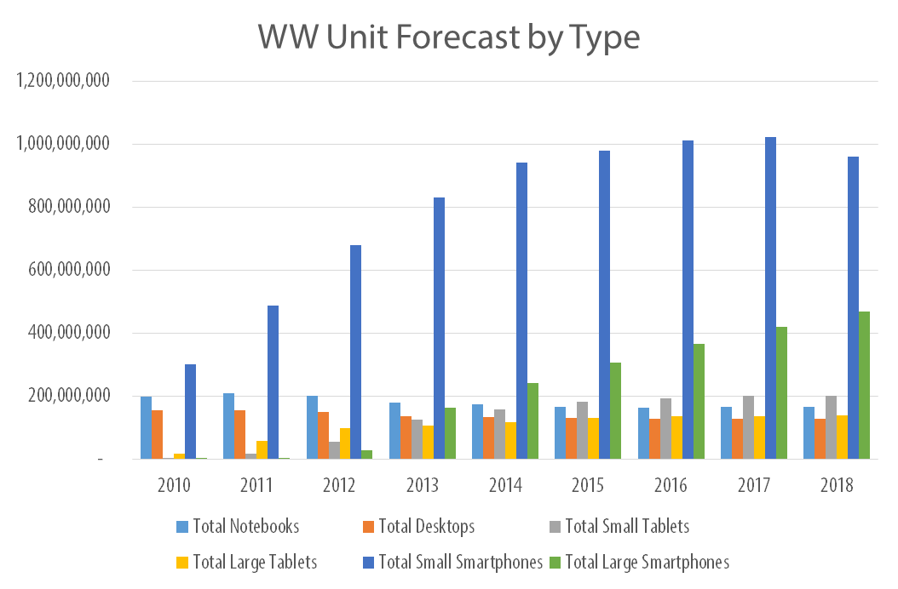

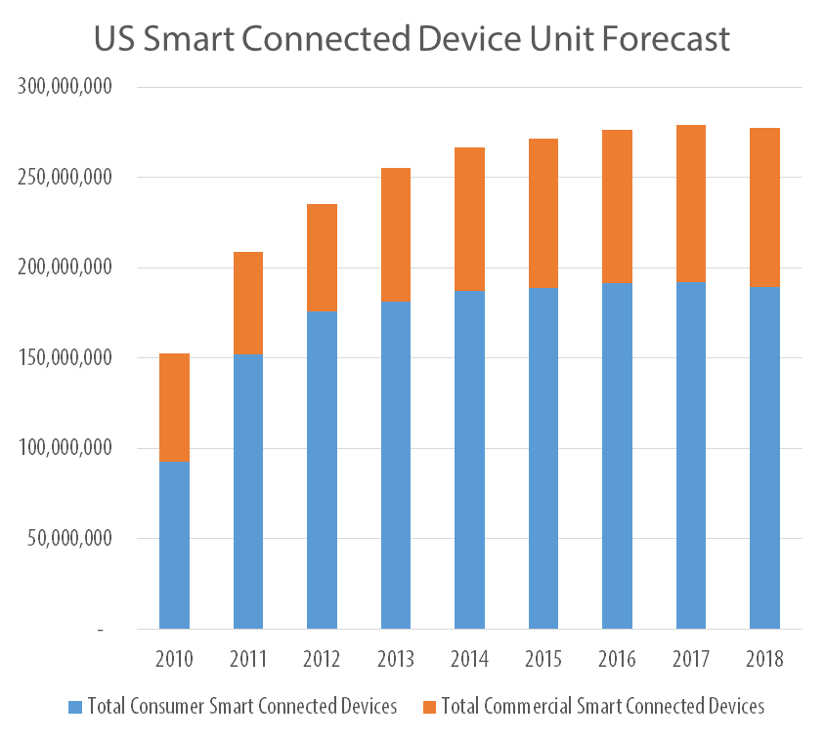

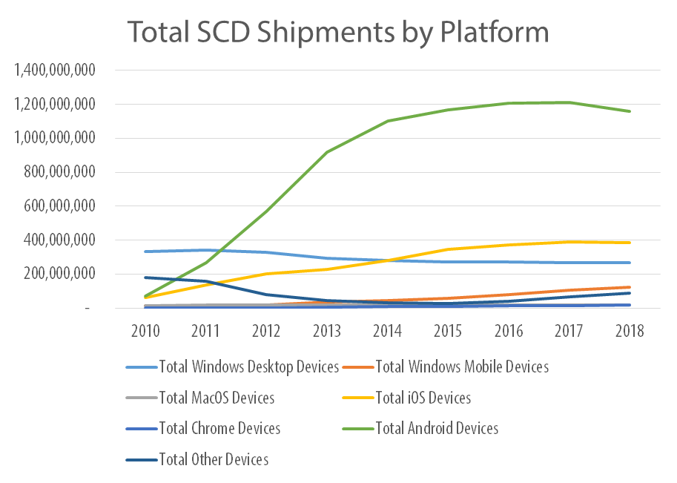
TECHnalysis Research is offering a free download of the top-level results of its forecast via its website at www.technalysisresearch.com. For additional information, please e-mail the author at bob@technalysisresearch.com.
Founded by technology market research veteran Bob O’Donnell, TECHnalysis Research, LLC provides strategic consulting and market research services to the technology industry and professional financial community. Building on a deep understanding of critical technology and business trends, in conjunction with hard-hitting, original research, the firm provides unique "out-of-the-box" perspectives that are still grounded in the practical realities of the technology, media and telecom markets.

